Project Design Phase-II
Data Flow Diagram & User Stories

Date | 13 July 2026
Team ID | SWUID2026211408
Project Name | Stock Trading Application
Maximum Marks | 4 Marks

Data Flow Diagrams:
A Data Flow Diagram (DFD) is a traditional visual representation of the information flows within a system. A neat and clear DFD can depict the right amount of the system requirement graphically. It shows how data enters and leaves the system, what changes the information, and where data is stored.

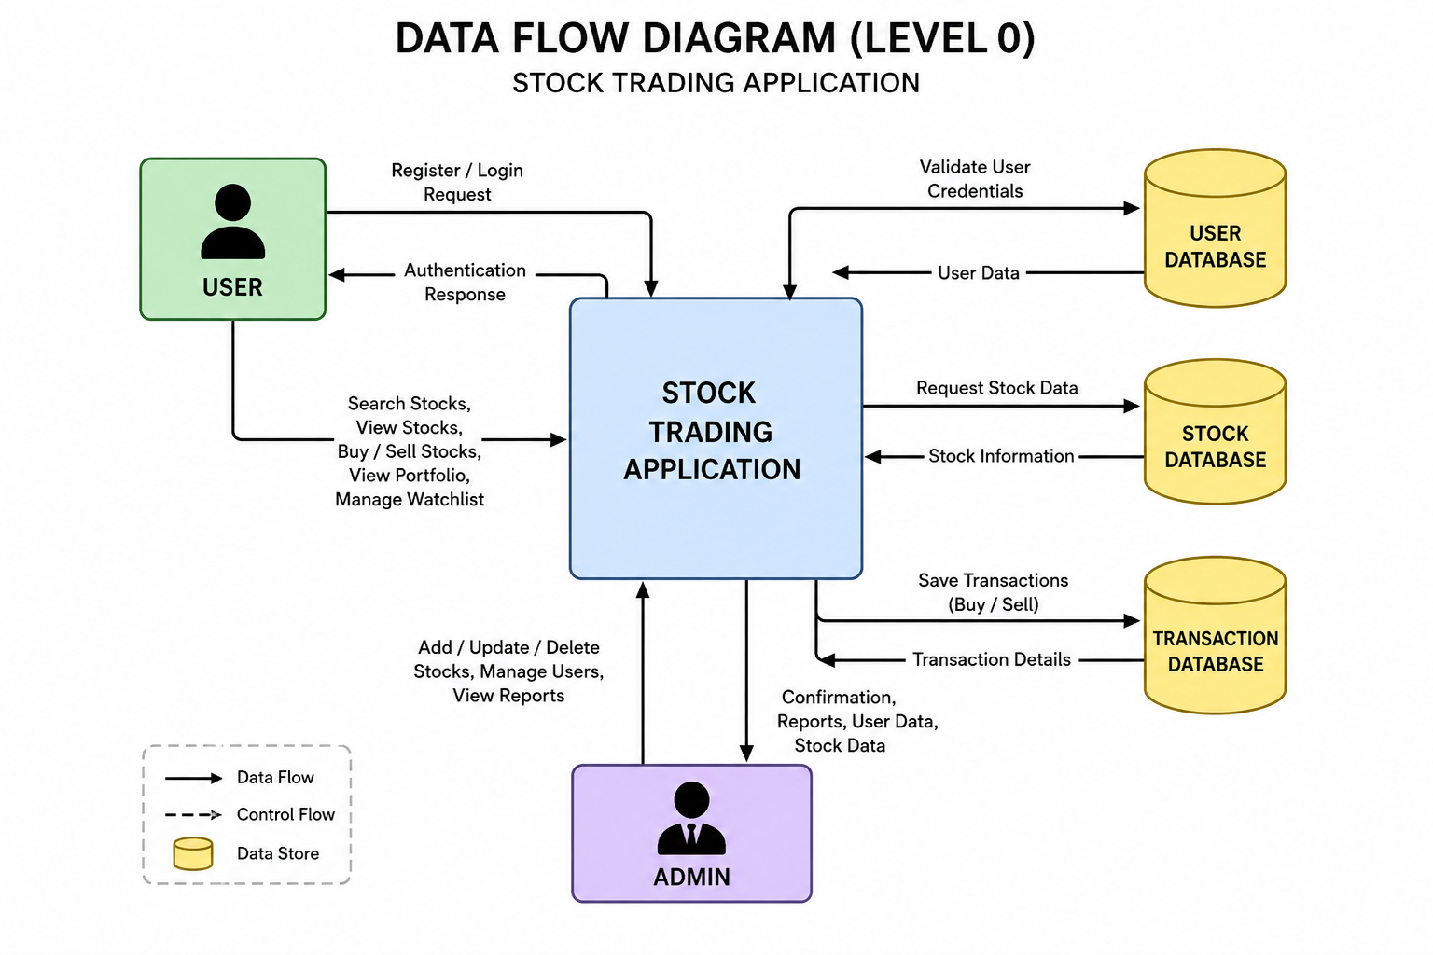
User Stories
Use the below template to list all the user stories for the product.
User Type | Functional Requirement (Epic) | User Story Number | User Story / Task | Acceptance Criteria | Priority | Release
Customer (Web User) | Registration | USN-1 | As a user, I can register using my name, email, and password. | User account is created successfully and dashboard is accessible. | High | Sprint-1
Customer (Web User) | Registration | USN-2 | As a user, I receive a confirmation message after successful registration. | Confirmation message is displayed successfully. | High | Sprint-1
Customer (Web User) | Login | USN-3 | As a user, I can log in using my registered email and password. | User is redirected to the dashboard after successful login. | High | Sprint-1
Customer (Web User) | Dashboard | USN-4 | As a user, I can view my dashboard with stock information. | Dashboard displays market overview and user details. | High | Sprint-1
Customer (Web User) | Stock Listing | USN-5 | As a user, I can view all available stocks with current prices. | Stock list loads correctly with updated information. | High | Sprint-2
Customer (Web User) | Search Stocks | USN-6 | As a user, I can search stocks by company name or stock symbol. | Matching stocks are displayed instantly. | Medium | Sprint-2
Customer (Web User) | Stock Charts | USN-7 | As a user, I can view graphical price trends for selected stocks. | Interactive stock chart is displayed successfully. | High | Sprint-2
Customer (Web User) | Buy Stocks | USN-8 | As a user, I can buy available stocks. | Purchased stocks are added to my portfolio. | High | Sprint-3
Customer (Web User) | Sell Stocks | USN-9 | As a user, I can sell stocks from my portfolio. | Sold stocks are removed and transaction is recorded. | High | Sprint-3
Customer (Web User) | Portfolio | USN-10 | As a user, I can view my investment portfolio and transaction history. | Portfolio displays holdings and transaction details accurately. | High | Sprint-3
Customer (Web User) | Watchlist | USN-11 | As a user, I can add or remove stocks from my watchlist. | Watchlist updates successfully. | Medium | Sprint-4
Customer Care Executive | Customer Support | USN-12 | As a customer care executive, I can respond to customer queries and issues. | Customer requests are managed efficiently. | Medium | Sprint-4
Administrator | Stock Management | USN-13 | As an administrator, I can add, update, and delete stock information. | Stock records are managed successfully. | High | Sprint-4
Administrator | User Management | USN-14 | As an administrator, I can monitor registered users and their activities. | User information is displayed and managed correctly. | Medium | Sprint-4
Administrator | Reports | USN-15 | As an administrator, I can generate reports on transactions and user activities. | Reports are generated accurately. | Medium | Sprint-4

z

Summary:
The Stock Trading Application supports secure user registration, authentication, stock browsing, buying and selling of stocks, portfolio management, watchlist functionality, and administrator controls for stock and user management. The user stories are distributed across four sprints to ensure incremental development and successful project completion.

